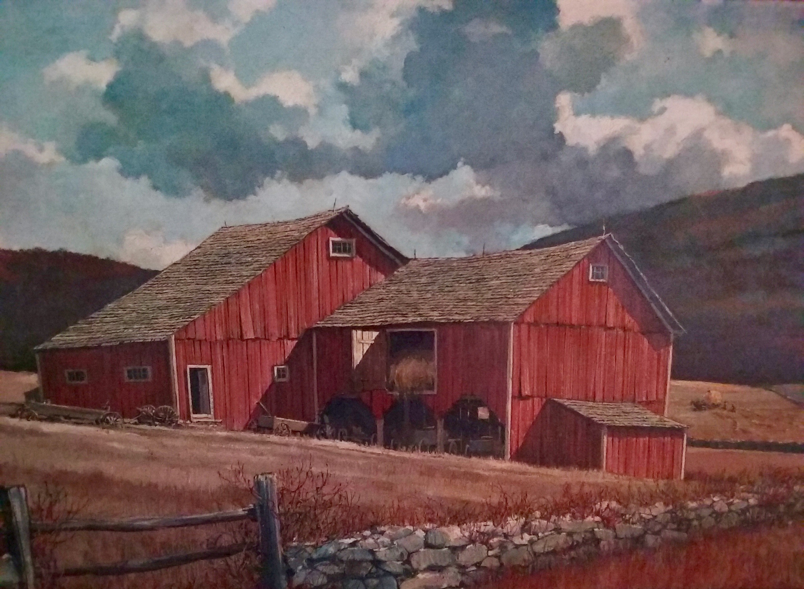

On October 14, 2017, the Friends of the Eric Sloane Museum are throwing a Harvest Party to raise money for the Noah Blake Cabin Restoration Fund…

…and you are invited!

4-6 p.m. at the Eric Sloane Museum
Kent, CT

*$10 admission per person as a donation * Dinner is on us * Local Craft Beers courtesy of Kent Falls Brewing Company * Free Admission to the Museum * Bonfire * Silent Auction including works by Sloane * Original works of art for sale by Eric Sloane * Special tours of the Cabin * Historic displays related to building in America, c. 1805 * Door prizes

You won’t want to miss this event!

